EEZ BB3+ wire harness
This is a wire harness for the EEZ BB3+ chassis.

The additional wire harness specification for power modules can be found at https://github.com/eez-open/dib-dcp405plus/tree/main/fabrication/wire%20harness
- Cooling fan cable
- TFT module FFC cable

Cooling fan cable
Total length | 70 (± 5) mm
Type | 3 wire, already mounted on the cooling fan
Fan: | TME: MF92251V1-G99-A  LCSC: C55123210  Mouser: 369-MF92251V1100UG99
 | 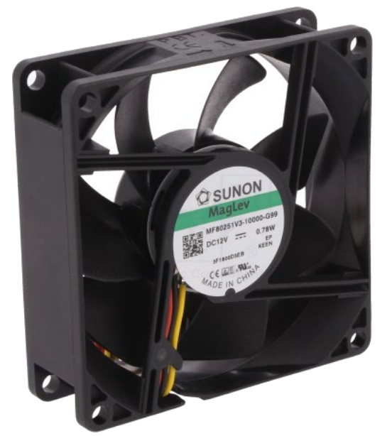
Connectors
Side A | X13 | Side B | N/A
Housing type | Receptacle, 0.1” | Fan is already equipped with cable. Therefore it only has to be terminated with the connector on side A.
TME | MX-22-01-3037
LCSC | C185238
Mouser | 538-22-01-3037
 | 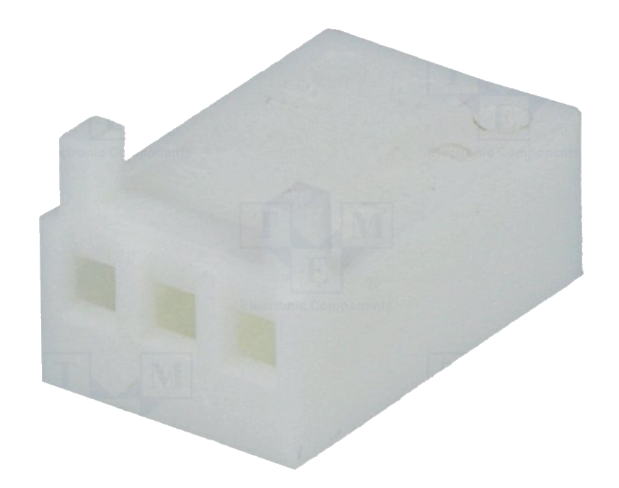
Pin | Female
Pin quantity | 3
TME | MX-0850-0114
LCSC | C45408619
Mouser | 538-08-50-0114
 | 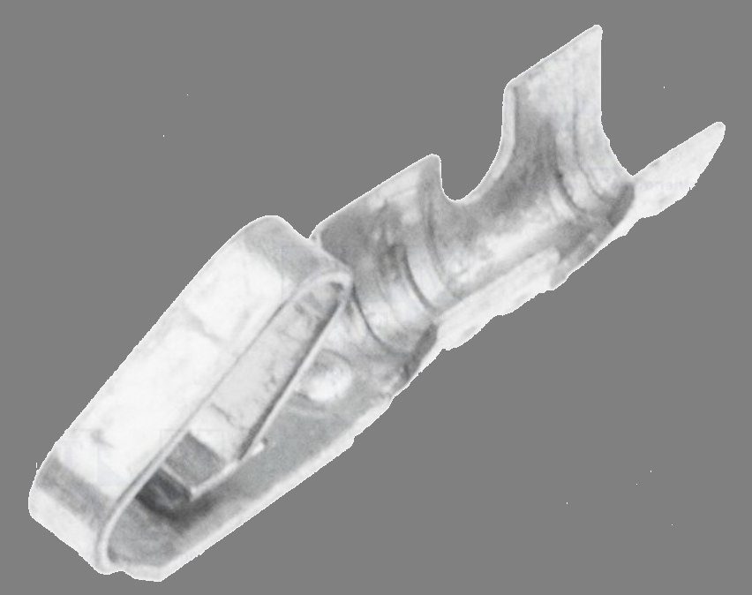

Wiring

Name | Position | Color / description
GND | 1 | Black
+12 Vdc | 2 | Red
Tacho | 3 | Yellow

Picture

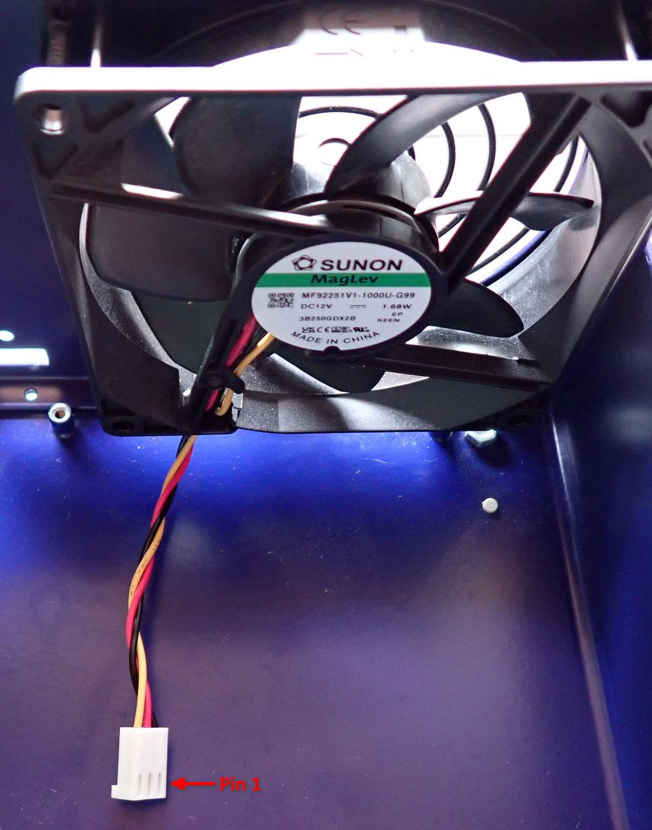

TFT module FFC cable
Length | 101 mm, 0.5 mm pitch, 22 pin
Type | Assembled ribbon cable with IDC connectors; 16x28AWG
TME | 05-22-A-0101-A
LCSC | C18024481
Mouser | 640-522A0101A4064T

Picture

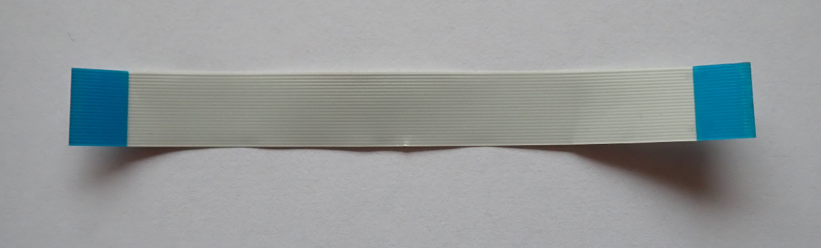

BOM
The following BOM includes items for connecting two power modules.

Type | Part (TME) | Part (LCSC) | Part (Mouser) | Total
3-pin 0.1” receptacle | MX-22-01-3037 | C185238 | 538-22-01-3037 | 1
0.1” pin | MX-0850-0114 | C45408619 | 538-08-50-0114 | 3
TFT module FFC cable | 05-22-A-0101-A | C18024481 | 640-522A0101A4064T | 1
12 Vdc cooling fan | MF80251V3-1000U-G99 | – | – | 1

